A

Project Report on

**Stock Market Prediction**

Submitted in partial fulfillment of completion of the course

Advanced Diploma in IT, Networking and Cloud Computing

Submitted by:

**Anju Luthra**

**Vidushi Garg**

|  |  |  |
| --- | --- | --- |
| IBM-Logo - Chicago Innovation | DGT introduces high end diploma courses - digitalLEARNING Magazine | Edunet Foundation-Delhi- CSR Organization profile |

Year 2022-2024

In

NSTI Noida (W)

D-1, Block D, Sector 1, Noida, Uttar Pradesh 201301

**Abstract**

This project delves into the dynamic realm of stock market analysis, utilizing the powerful yfinance library alongside essential data science tools such as numpy, pandas, and matplotlib. The integration of machine learning, specifically employing the scikit-learn library for linear regression, enhances our ability to make informed predictions. Evaluation metrics, including mean squared error, mean absolute error, and R-squared, contribute to a comprehensive assessment of model performance. Moreover, the project explores the application of confusion_matrix for assessing classification accuracy. Through this synthesis of financial data and advanced analytical techniques, the project aims to empower users with a robust toolkit for insightful stock market analysis.

**Acknowledgement**

We would like to express our sincere gratitude to several individuals and IBM organization for supporting us throughout our diploma study. First, we wish to express our sincere gratitude to our Edunet mentor, Miss Mala Mishra and Miss Ankita Shukla for their enthusiasm, patience, insightful comments, helpful information, practical advice and unceasing ideas that have helped us tremendously at all times in our study and writing of this project report.

We also wish to express our sincere thanks to our course co-ordinator, Mr. D.A.Guruvulu ,for his valuable suggestions and guidance.

We extend our sincere thanks to our respected Head of the division Smt. Shashi Mathur [JD NSTI(W) NOIDA], for allowing us to use the facilities available.

In addition, we are deeply indebted to the Ministry of Skill Development & Entrepreneurship and IBM for granting us the diploma course. Their technical and financial support has enabled us to complete our diploma course studies successfully

**ADVANCE DIPLOMA IN IT NETWORKING**

**& CLOUD COMPUTING**

**_______________________________________________**

The Advanced Diploma in IT Networking and Cloud Computing program offered by NSTI (W) Noida in collaboration with Edunet Foundation is a comprehensive course designed to equip students with advanced skills in information technology and cloud computing. This program covers a wide range of topics, including Computer Networking, Database Management, Virtualization, Cloud Technologies, and Cybersecurity. Students will gain hands-on experience through practical labs, workshops, and real-world projects, enabling them to excel in the rapidly evolving IT industry. Upon completion of the program, Graduates will have a strong foundation in both IT Fundamentals and Cloud Computing, making them highly sought-after professionals in the field.

**Project Requirements**

|  |  |
| --- | --- |
| **Project Name** | **Stock Market Analysis** |
| **Languages Used** | **Python** |
| **Editor** | **Jupyter Notebook, Google Colab** |
| **Web Browser** | **Google Chrome, Microsoft Edge** |

**Team Composition and Workload Division**

|  |  |
| --- | --- |
| Vidushi | Data Analysis, Synopsis |
| Anju Luthra | Data Analysis, Synopsis |

**Tables of Content**

|  |  |  |
| --- | --- | --- |
| **SNO** | **TOPIC** | **Page No** |
| 1. | PROBLEM STATEMENT | 5 |
| 2. | REQUIREMENTS SPECIFICATION | 5-6 |
| 3. | OVERVIEW | 6 |
| 4. | PROJECT MODULE | 6 |
| 5. | SAMPLE SCREENSHOTS | 7-8 |
| 6. | SOURCE CODE | 9 |
| 7. | FUTURE SCOPE | 10 |
| 8. | CONCLUSION | 10 |
| 9. | REFERENCES | 10 |

1. **Introduction to Problem**

In the dynamic landscape of financial markets, making informed investment decisions is critical for maximizing returns and mitigating risks. The sheer volume of available data, coupled with the complexity of market dynamics, necessitates robust analytical tools. This project addresses the challenge of comprehensively analyzing stock market data, emphasizing data visualization and predictive modeling.

The problem at hand involves leveraging historical stock data to gain insights into market trends and patterns. This analysis aims to go beyond traditional methods by incorporating data visualization techniques such as candlestick charts, moving averages, and volume analysis. Furthermore, the project seeks to predict future stock prices using both elementary models, like simple moving averages and linear regression, and more advanced time series forecasting techniques with the Prophet library.

By delving into these aspects, the project aims to equip investors and analysts with a practical and data-driven approach to navigate the complexities of financial markets. The focus is on providing a toolkit that empowers users to visualize historical performance, identify potential investment opportunities, and make informed decisions in the ever-evolving landscape of stock trading.

1. **Requirements**

**3.1 Technology Stack**

**Python:** High-level programming language used for server-side scripting.

**Google Colab**: short for Colaboratory, is a free, cloud-based platform provided by Google that allows users to create, share, and run Jupyter notebooks. It offers pre-installed libraries for data science and machine learning, provides free access to GPUs and TPUs, and integrates seamlessly with Google Drive for collaborative and easily shareable coding projects

**3.2 Hardware**

Laptop/ Computer

**3.3 Software**

Operating System (OS)

Version Control System

Text Editors and Integrated Development Environments (IDEs)

1. **Overview**

The data analysis project aims to investigate and derive meaningful insights from a specific dataset. It involves collecting, cleaning, and processing raw data to uncover patterns, trends, and correlations. Using statistical methods and visualization tools, the project seeks to provide a comprehensive understanding of the data, enabling informed decision-making. The analysis may involve exploring relationships between variables, identifying outliers, and creating predictive models. Throughout the project, a systematic approach is followed, including hypothesis testing and validation of results. The ultimate goal is to offer actionable recommendations or conclusions based on the data findings. The project typically employs programming languages such as Python or R, along with tools like Jupyter Notebooks, to facilitate a transparent and reproducible analytical workflow. Overall, the data analysis project serves to extract valuable insights, enhance understanding, and support evidence-based decision-making in a given domain.

1. **Project Module**
   1. Import the required libraries.
   2. Load/ Read the Dataset
   3. Prepare EDA
   4. Do Visualizations
   5. Do the Prediction
   6. Evaluation of Model

**6 Sample Screenshots**

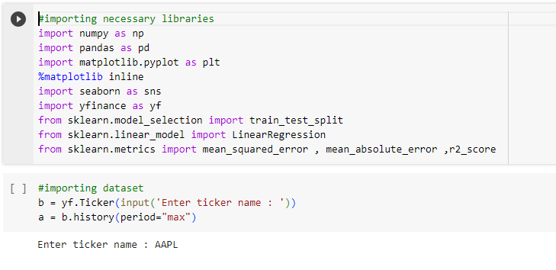

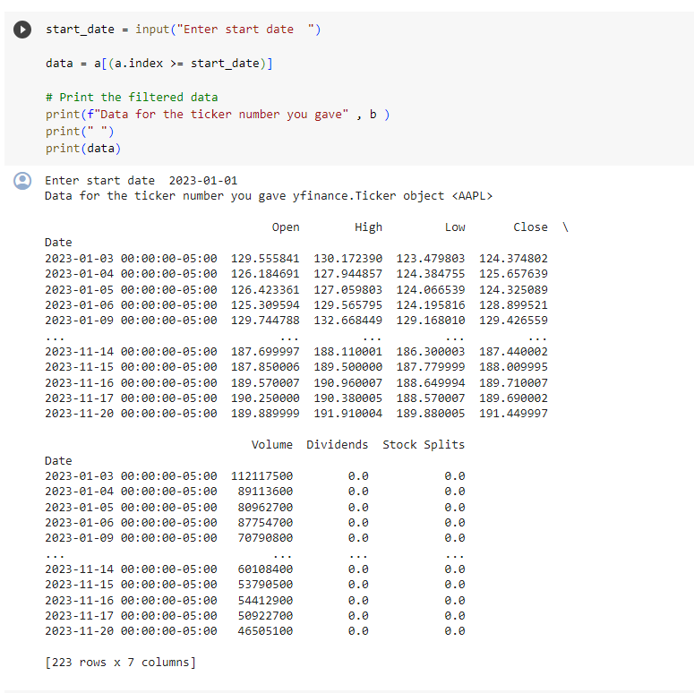

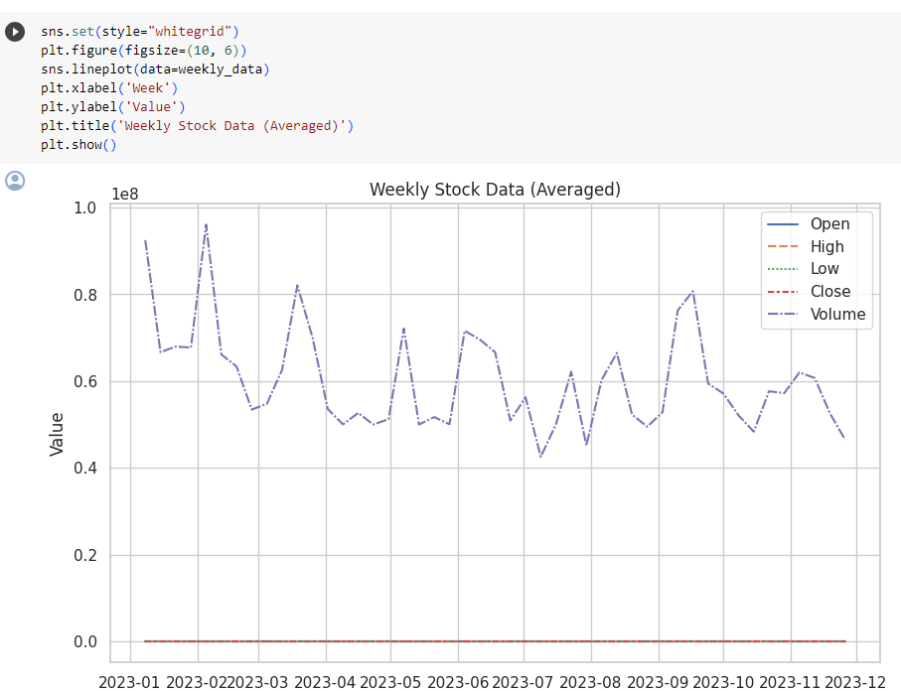

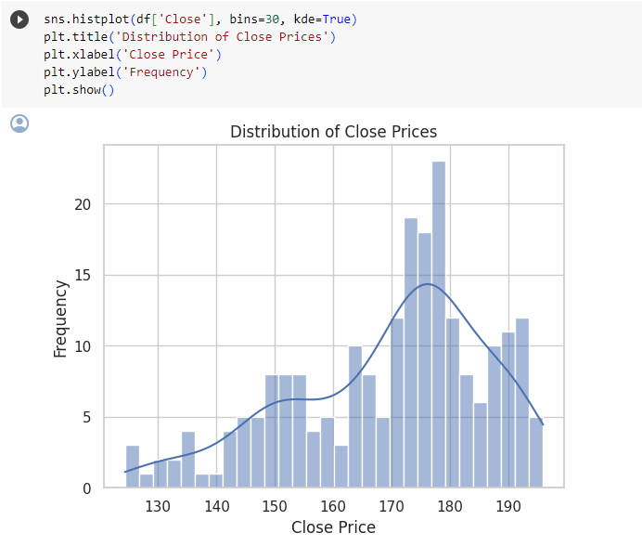

**7 Source Code**

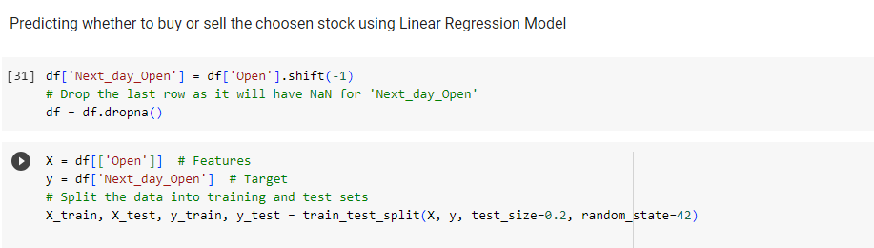

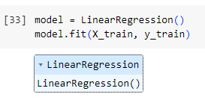

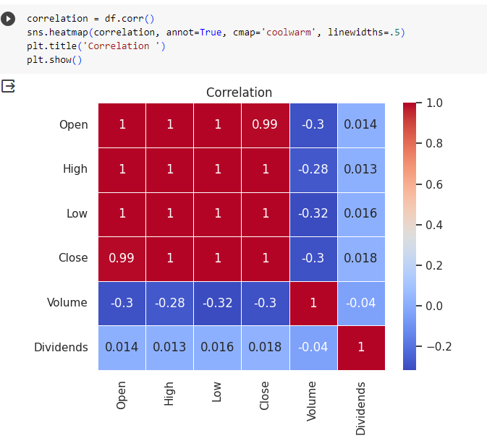

**8 Future Scope**

The future scope of stock market analysis includes increased use of machine learning and AI, advancements in quantitative finance, integration of blockchain technology, reliance on alternative data sources, automation with robo-advisors, emphasis on cybersecurity, and exploration of decentralized finance (DeFi). Additionally, there will likely be a continued focus on global economic factors, ESG criteria, and educational platforms for democratizing access to stock market insights.

**9 Conclusion**

In conclusion, the evolving landscape of stock market analysis presents exciting opportunities for leveraging advanced technologies and data-driven strategies. The integration of machine learning, blockchain, and big data analytics is poised to enhance predictive modeling and decision-making. The increasing role of alternative data sources and automation tools reflects a shift towards more comprehensive and efficient market insights. As the financial industry embraces decentralized finance and emphasizes factors like ESG criteria, the future holds a dynamic and interconnected ecosystem. However, it's crucial to adapt to regulatory changes, prioritize cybersecurity, and promote financial education to ensure a well-informed and resilient approach to stock market analysis in the years to come.

**10 References**

<https://finance.yahoo.com/>

**Thank You**